**United States Department of Agriculture**

Food and Nutrition Service

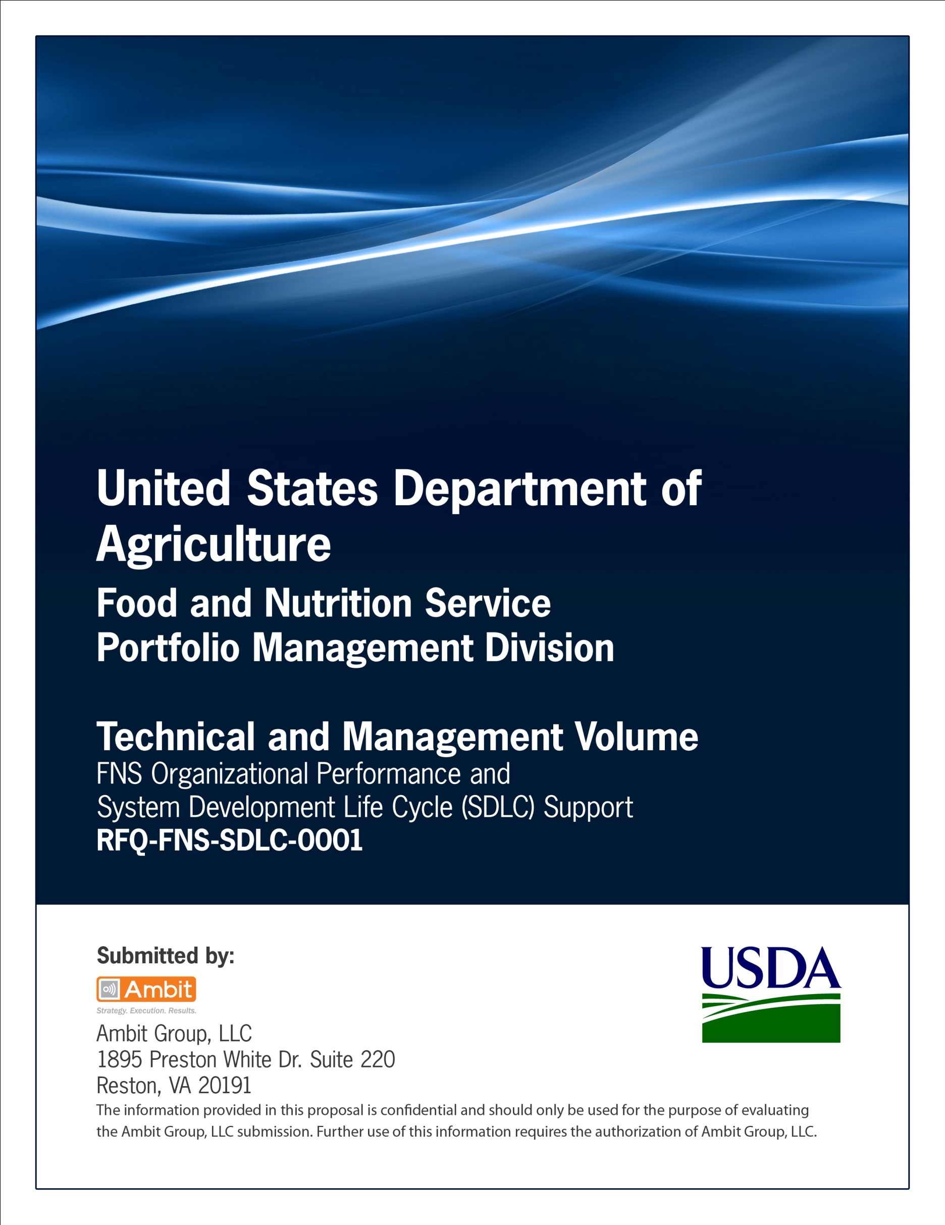

**Office of Information Technology**

**Portfolio Management Division (PMD)**

**FNS Performance Work Statement Template**

**for**

**[Project or System Name]**

**Version 1.1**

September 09, 2013

**Revision History**

|  |  |  |  |
| --- | --- | --- | --- |
| **Version** | **Date** | **Author** | **Change Description** |
| 1.0 | 03-21-2013 | IT Governance Branch (ITGB) | Created the document. |
| 1.1 | 09-09-2013 | IT Governance Branch (ITGB) | Re-formatted the document. |
| 1.2 |  |  |  |
| 1.3 |  |  |  |

**Contact Information**

|  |  |
| --- | --- |
| **Area of Concern** | **Contact Person** |
| IT Governance Lead | Kevin Russ |
| SDLC Coordinator | Syed Jaffery |
| ITIRB Coordinator | Sunny Dilawari |
| Portfolio Management Division Director, Chief Portfolio Officer | Jacqueline Butler |
| Program Management Branch Chief | Allison Willcox |

Contents

Glossary 3

1. Introduction 4

1.1. Organization 4

1.2. Background 4

1.3. Purpose 4

2. Scope of Work 4

3. Task Objectives and Deliverables 4

3.1. Task: <Name of Task 1> 4

3.2. Task : < Name of Task 2> 4

4. Constraints 4

5. Special Requirements 4

5.1. Disclosure of Information 4

5.2. Security Requirements 5

5.3. Access to Government Computers 5

5.4. Government Furnished Equipment/Facilities 5

5.5. Section 508 Compliance 5

6. Task Management 5

6.1. Program Management Plan 5

6.2. Quality Assurance Plan 5

6.3. Monthly Program Management Summary 6

6.4. Weekly Status Reports 6

6.5. Itemized List and Due Dates 6

7. Period, Hours, and Security 6

Appendix A: Section 508 VPAT 7

Appendix B: Section 508 Language for Software Development Services 8

Appendix C: Section 508 Language for Software Maintenance Services 9

Appendix D: References 10

Approvals/Signatures 11

# Glossary

| **Acronym** | **Description** |
| --- | --- |
|  |  |
|  |  |
|  |  |
|  |  |
|  |  |
|  |  |
|  |  |
|  |  |

# Introduction

## Organization

Describe the organization.

## Background

Describe the background of the system for which the PWS is prepared.

## Purpose

Describe the purpose of the performance work statement.

# Scope of Work

Provide a description of the scope of work.

# Task Objectives and Deliverables

## Task: <Name of Task 1>

**Objectives**

Describe the objectives of Task 1.

**Required Services**

Describe the required services under Task 1.

## Task : < Name of Task 2>

**Objectives**

Describe the objectives of Task 2.

**Required Services**

Describe the required services under Task 2. Continue as needed.

# Constraints

Describe the constraints for scope of work covered under this PWS.

# Special Requirements

## Disclosure of Information

Provide the disclosure of information requirements.

**Request for Approval for Release of Information**

Provide the request for approval for release of information.

**Disclosure Constraints**

Provide the disclosure constraints.

## Security Requirements

Provide the security requirements.

**Security Clearances**

Provide the security clearances requirements.

**Training**

Provide the security training requirements.

## Access to Government Computers

Provide the requirements for the access to Government computers.

## Government Furnished Equipment/Facilities

Provide the requirements for Government Furnished Equipment/Facilities.

## Section 508 Compliance

Under Section 508 (29 U.S.C.  794d), agencies must give disabled employees and members of the public access to information that is comparable to the access available to others.

The Standard language for Section 508 for Software Development Services (refer to Appendix 2) or the Software Maintenance Services (refer to Appendix 3) should be inserted based on the nature of the acquisition for which the PWS is being developed.

# Task Management

## Program Management Plan

The Program Management Plan contains all the key information about how a contract will be managed.  It establishes systems and processes to ensure that the contractor complies with the terms and conditions during the performance of the contract This section describes the requirements for the program management plan and the time of submission of the program management plan by the vendor to the Government.

## Quality Assurance Plan

The Quality Assurance Plan will outline how the contractor will ensure that it performs and delivers high-quality service. This section describes the requirements for the quality assurance plan and the time of submission of the quality assurance plan by the vendor to the Government.

## Monthly Program Management Summary

The Contractor shall provide a monthly management report that summarizes the Contractor’s previous month’s activities including any management issues, status, recommendations, and suggested resolutions. This section describes the requirements for the monthly program management summary and the time of submission of program management summary by the vendor to the Government.

## Weekly Status Reports

The Contractor shall provide a weekly status report that details the Contractor’s previous week’s activities including any management issues, accomplishments, status, user requests, schedule changes, recommendations, suggested resolutions, and upcoming assignments. his section describes the requirements for the weekly status reports and the time of submission of the weekly status reports by the vendor to the Government.

## Itemized List and Due Dates

This section describes the itemized list of deliverables and the due dates.

# Period, Hours, and Security

Provide the period of performance, the hours of work and the security constraints.

# Appendix A: Section 508 VPAT

Provide the enclosed Section 508 VPAT with the appropriate sections to be filled out by the vendors.

**

**

# Appendix B: Section 508 Language for Software Development Services

Solicitation Language for Software Development Services

The suggested language below should be cut and pasted into the solicitation documentation when a Section 508 Program Need is determined for a service. The Government Product/Service Accessibility Template (GPAT) must also be included in this documentation.

Section 508 Program Need

Requirements for accessibility based on Section 508 of the Rehabilitation Act of 1973 (29 U.S.C. 794d) are determined to be relevant for the following program need: "Software Development."

Section 508 Deliverable Requirements

The activity to be performed relates to or requires the use of EIT. Section 508 must be considered as a requirement for Software Development service outputs/deliverables to ensure that it considers specific Section 508 accessibility requirements. Further, Software Development outputs/deliverables should not adversely affect accessibility features of existing EIT technologies. Technical standards from 36 CFR part 1194 Subpart B have been determined to apply to this acquisition. Solicitation respondents must describe how their background and experience will enable them to at least meet those technical provisions identified as applicable in the attached Government Product/Service Accessibility Template (GPAT).

Software Development outputs/deliverables should meet applicable accessibility requirements and should not adversely affect accessibility features of existing EIT technologies.

Functional performance criteria from 36 CFR part 1194 Subpart C have been determined to apply to this acquisition. Solicitation respondents must describe how their background and experience will enable them to at least meet those functional performance criteria identified as applicable in the attached Government Product/Service Accessibility Template (GPAT).

Information, documentation, and support requirements from 36 CFR part 1194 Subpart D have been determined to apply to this acquisition. Solicitation respondents must describe how the information, documentation, and support proposed for Software Development outputs/deliverables will meet at least those information, documentation, and support requirements identified as applicable in the attached Government Product/Service Accessibility Template (GPAT).

**Section 508 Evaluation Factors**

Responses to this solicitation will only be considered for award after it has been determined that the proposal adequately addresses the requirements for Section 508. Only proposals which contain adequate information to document their responsiveness to the Section 508 requirements (e.g. accessibility capabilities and past performance) will be eligible for any additional merit consideration.

**Section 508 Acceptance Criteria**

Software Development outputs/deliverables resulting from this solicitation will be accepted based in part on satisfaction of identified Section 508 requirements for accessibility. Software Development outputs/deliverables must include a completed GPAT, a sample of which is included as a part of this solicitation.

Software Development outputs/deliverables should meet applicable accessibility requirements and should not adversely affect accessibility features of existing EIT technologies.

# Appendix C: Section 508 Language for Software Maintenance Services

**Solicitation Language for Software Maintenance Services**

The suggested language below should be cut and pasted into the solicitation documentation. The GPAT must also be included in this documentation.

**Section 508 Program Need**

Requirements for accessibility based on Section 508 of the Rehabilitation Act of 1973 (29 U.S.C. 794d) are determined to be relevant for the following program need: "Software Maintenance Service."

**Section 508 Deliverable Requirements**

The activity to be performed relates to or requires the use of EIT. Section 508 must be considered as a requirement for Software Maintenance Service to assure that it considers specific Section 508 accessibility requirements. Technical standards from 36 CFR part 1194 Subpart B have been determined to apply to this acquisition. Solicitation respondents must describe how their background and experience will enable them to at least meet those technical provisions identified as applicable in the attached Government Product/Service Accessibility Template (GPAT).

Functional performance criteria from 36 CFR part 1194 Subpart C have been determined to apply to this acquisition. Solicitation respondents must describe how their background and experience will enable them to at least meet those functional performance criteria identified as applicable in the attached Government Product/Service Accessibility Template (GPAT).

Information, documentation, and support requirements from 36 CFR part 1194 Subpart D have been determined to apply to this acquisition. Solicitation respondents must describe how the information, documentation, and support proposed for Software Maintenance Service outputs/deliverables will meet at least those information, documentation, and support requirements identified as applicable in the attached Government Product/Service Accessibility Template (GPAT).

**Section 508 Evaluation Factors**

Responses to this solicitation will only be considered for award after it has been determined that the proposal adequately addresses the requirements for Section 508. Only proposals which contain adequate information to document their responsiveness to the Section 508 requirements (e.g. accessibility capabilities and past performance) will be eligible for any additional merit consideration.

**Section 508 Acceptance Criteria**

Software Maintenance Service outputs/deliverables resulting from this solicitation will be accepted based in part on satisfaction of identified Section 508 requirements for accessibility. Software Maintenance Services outputs/deliverables must include a completed GPAT, a sample of which is included as a part of this solicitation.

Software Maintenance Service outputs/deliverables should meet applicable accessibility requirements and should not adversely affect accessibility features of existing EIT technologies.

# Appendix D: References

Insert the name, version number, description, and physical location of any documents referenced in this document. Add rows to the table as necessary.

The following table summarizes the documents referenced in this document.

|  |  |  |
| --- | --- | --- |
| **Document Name** | **Description** | **Location** |
| Document Name and Version Number | Document description | URL or Network path where document is located |
|  |  |  |
|  |  |  |

# Approvals/Signatures

The undersigned acknowledge that they have reviewed the [name of document] document and agree with the information presented within this document. Changes to this document will be coordinated with, and approved by, the undersigned, or their designated representatives.

|  |  |  |  |
| --- | --- | --- | --- |
| Signature: |  | Date: |  |
| Print Name: |  |  |  |
| Title: |  |  |  |
| Role: | [Project or System Name] Project Manager |  |  |
|  |  |  |  |
| Signature: |  | Date: |  |
| Print Name: |  |  |  |
| Title: |  |  |  |
| Role: | [Project or System Name] Business Owner |  |  |
|  |  |  |  |
| Signature: |  | Date: |  |
| Print Name: |  |  |  |
| Title: |  |  |  |
| Role: | Organization’s Approving Authority |  |  |